LAB 6
Aggregate Functions

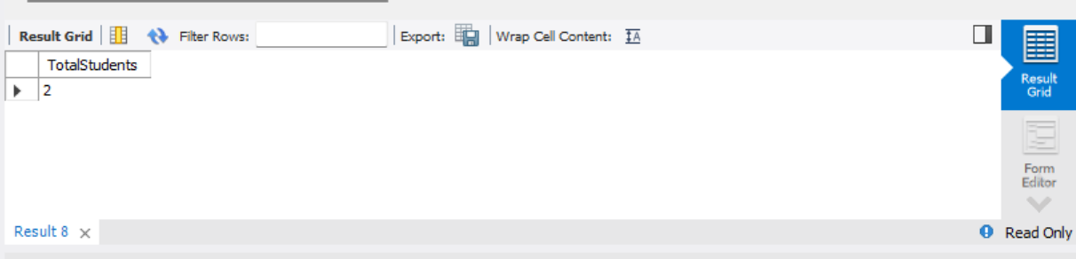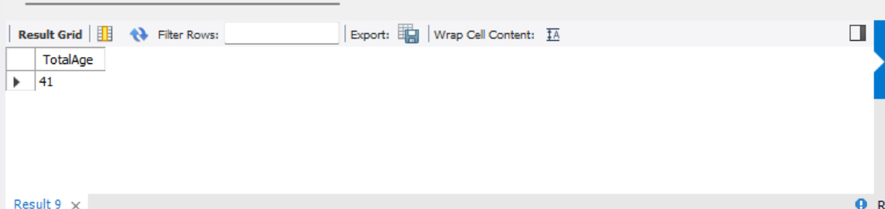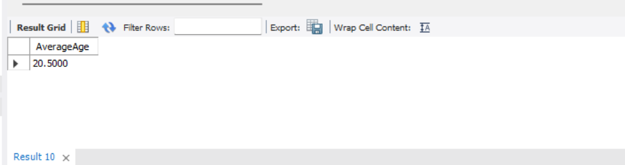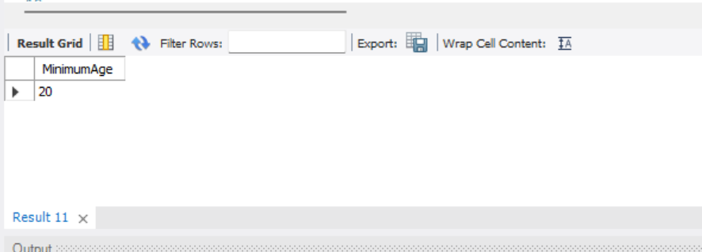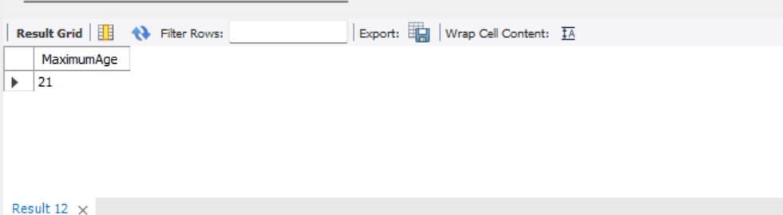

- COUNT(): Displays the total number of students.
- SUM(): Displays the total sum of students' ages.
- AVG(): Displays the average age of students.
- MIN(): Displays the minimum age of students.
- MAX(): Displays the maximum age of students.

